

Introduction To Database Systems - LAB

Project Phase 03

**Metro Train Management System**

Submitted by

| Muhammad Sinnan Hamid | L1F21BSSE0036 |
| --- | --- |
| Hafiz Faizan Ahmed | L1F21BSSE0030 |

Submitted to

MR. Khizar Khiyat

Submission date:

2023-01-30

**Metro Management System**

**Queries**

**Question 01**

Display data of train whose capacity is > 100, Departure time is between 08 and 20, its ticket cost is > 500 and its on line that serve more than 3 stations. (Joins)

**SELECT**

t.*

**FROM**

train t

INNER JOIN

schedules s ON t.train_ID = s.train_id

JOIN

station st ON st.train_ID = t.train_Id

JOIN

line l ON st.line_id = l.line_id

RIGHT JOIN

fare f ON f.line_ID = l.line_ID

**WHERE**

st.capacity >= 100

AND s.departure_time > '08:00:00'

AND s.departure_time < '20:00:00'

AND l.Station_Served > 3

AND f.cost > 500;

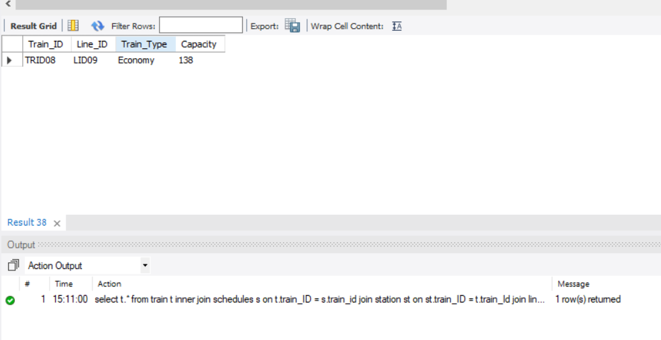

**Question 02**

Display cost of the ticket and name of those customers whose date of purchase of ticket is between ‘2019’ and ‘2021’ and their fare type is ‘Economy’ OR ‘Business’. (Joins)

**SELECT**

c.name, f.cost

**FROM**

customer c

INNER JOIN

Ticket t ON c.customer_Id = t.customer_Id

JOIN

fare f ON f.fare_ID = t.fare_ID

JOIN

Trip tr ON tr.trip_ID = c.Trip_ID

**WHERE**

t.Date_Of_Purchase BETWEEN '2019-01-01' AND '2021-12-31'

AND f.type LIKE 'Business'

OR f.type LIKE 'Economy';

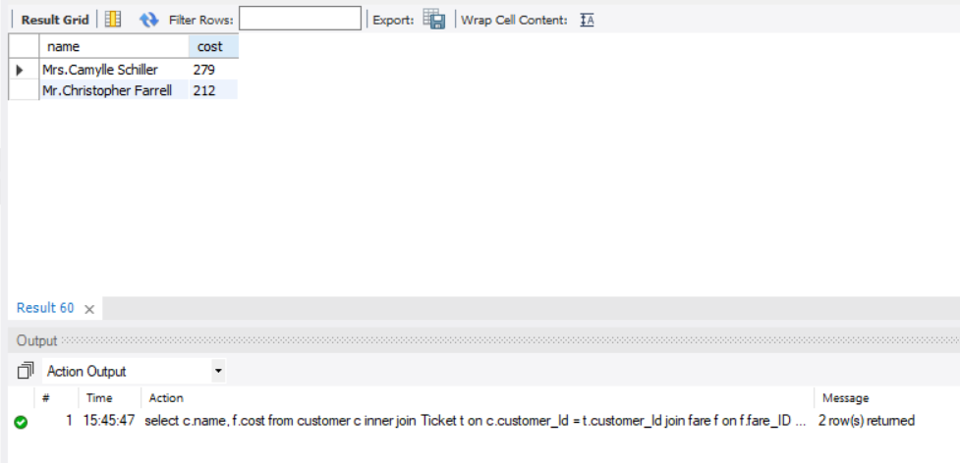

**Question 03**

Display Data of those Employees who do maintenance at trains where capacity is > 500 and Station name is ‘Lake’; (Nested)

**SELECT**

e.*

**FROM**

employee e

**WHERE**

e.Employee_ID IN (**SELECT** m.Employee_ID

FROM Maintenance m

WHERE m.train_ID IN (**SELECT** t.train_Id

**FROM** train t

**WHERE** t.capacity < 500

AND t.train_Id IN (**SELECT** train_id

**FROM** station

**WHERE** name LIKE 'Lake')));

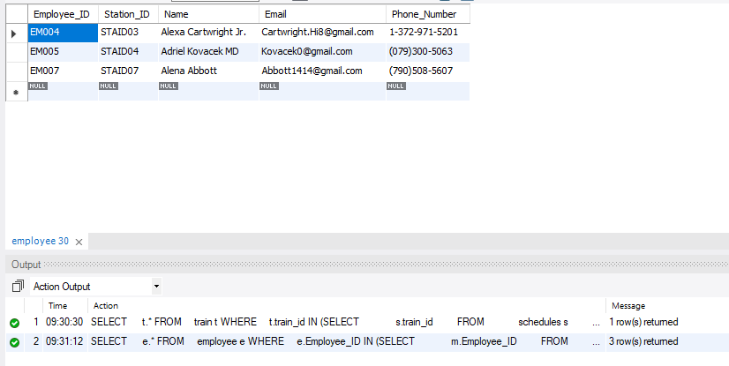

**Question 04**

Display all data of a train which runs on a station whose capacity is greater than 500. (Nested)

**SELECT**

t.*

**FROM**

train t

**WHERE**

t.train_id IN (**SELECT** s.train_id

**FROM** schedules s

**WHERE** s.station_ID = ANY (**SELECT** st.station_Id

**FROM** station st

**WHERE** st.capacity < 500

AND st.line_id IN (**SELECT** line_id

**FROM** line

**WHERE** capacity < 100)));

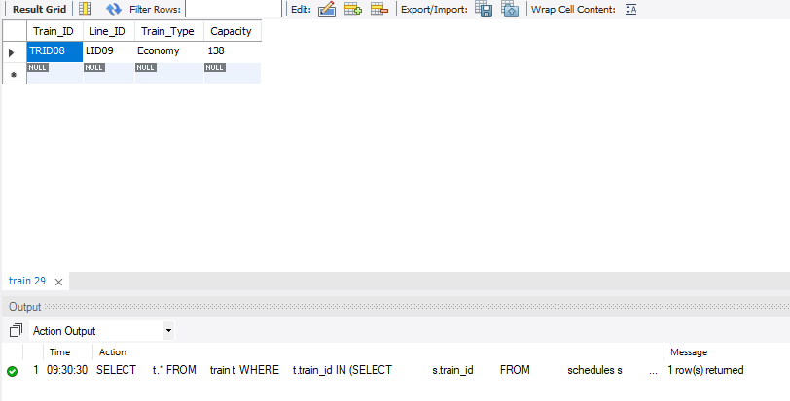

**Question 05**

Display all data of those Employees which runs on a line that serve more than 3 stations, have capacity greater than 500 and its fare cost is more than 100. (Joins)

**SELECT**

e.*

**FROM**

employee e

JOIN

station s ON e.station_Id = s.station_Id

JOIN

line l ON l.line_ID = s.line_ID

JOIN

fare f ON f.line_ID = l.line_ID

**WHERE**

l.Station_Served > 3

AND s.Capacity > 500

AND f.cost > 100;

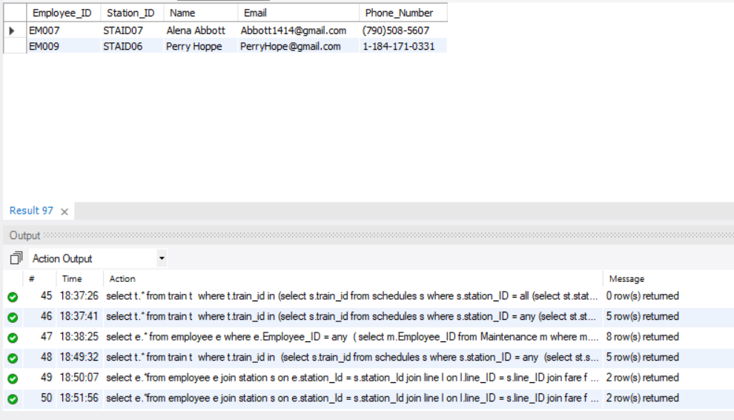

**Question 06**

Display information of employees who do different types of maintenance for the train. (Nested)

**SELECT**

e.*

**FROM**

employee e

**WHERE**

e.Employee_id IN (**SELECT** m.Employee_id

**FROM** Maintenance m

**WHERE** m.Type_od_Maintenance LIKE 'Small'

AND m.train_id IN (**SELECT** train_id

**FROM** train

**WHERE** capacity > 100

AND train_id IN (**SELECT** train_id

**FROM** station

**WHERE** name LIKE 'Lake')));

